**Bhesh Raj Neupane –Desgin Principle and Microserivce Architecure**

**Reference**

[**Mehmet Ozkaya**](https://medium.com/@mehmetozkaya?source=post_page-----1e4716fbca17--------------------------------)

[**https://medium.com/design-microservices-architecture-with-patterns**](https://medium.com/design-microservices-architecture-with-patterns)

**Monolithic Architecture** <https://medium.com/design-microservices-architecture-with-patterns/communications-in-monolithic-architecture-64f9fa901ba4>

When it comes to **communication in a monolithic architecture**, the application components communicate with each other through **direct method calls**or **function invocations**, often using shared libraries and common databases

* **The communication will be inter-process communication.**

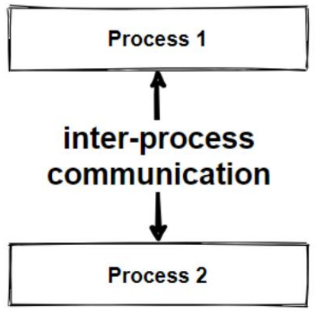

In a monolithic architecture, all of the application’s modules are deployed together on a single server or cluster, which means that the **communication**between modules happens within the **same process**, and there is **no need for network communication**.

**Scalability**

<https://medium.com/design-microservices-architecture-with-patterns/scalability-vertical-scaling-horizontal-scaling-adb52ff679f>

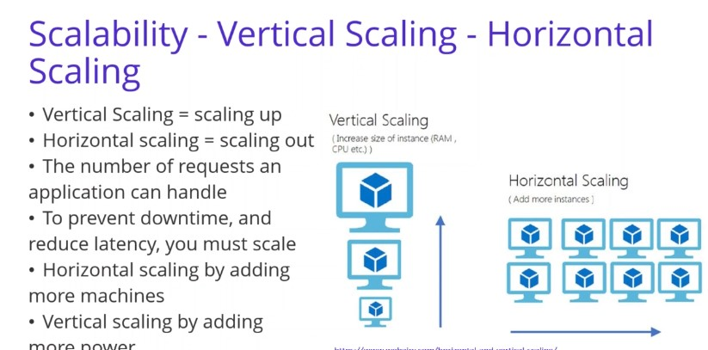

**Vertical scaling**is basically makes the **nodes stronger**. If you have 1 server, make the server stronger with **adding more hardware**. Make optimization the hardware that will allow you to handle more requests.

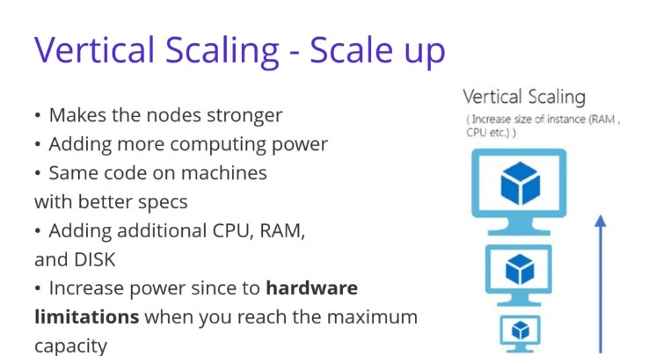

**Horizontal scaling**basically means splitting the load between different servers. Horizontal scaling simply **adds more instances** of machines without changing to existing specifications. By scaling out, you can share the processing power and load balancing across multiple machines. **(Best practices- Scale Out , handles millions of requests )**

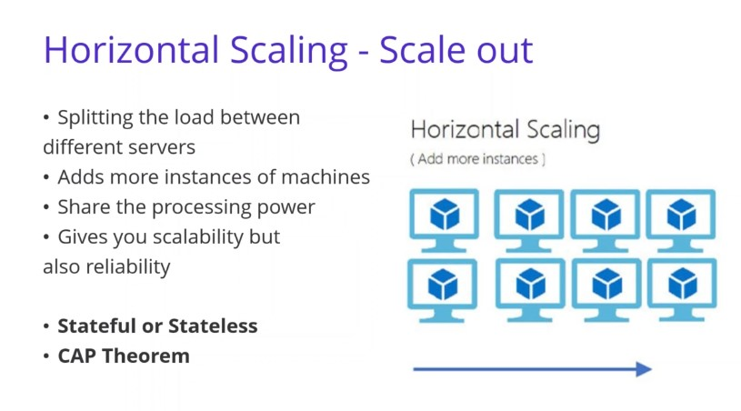

**Load Balancer**

load balancers that **balance the traffic**across to all nodes of our applications. Mostly Load balancer is a software application that helps to spread the traffic across a cluster of servers to **improve responsiveness** and availability of the architecture.

 Load Balancer sits between the client and the server.

Load Balancer is **accepting incoming network** and application traffic and **distributing the traffic** across multiple backend servers using different algorithms

Mostly using consistent hashing algorithms.

**NGINX**is one of the popular open-source load balancing software that widely using in the software industry.

Main features of Load Balancers should be fault tolerance and improves availability. That means if one of the**backend server**is down, all the traffic will be routed to the rest of the services accordingly from **Load Balancer.**Also if the traffic is growing rapidly, you only need to add more servers and the load balancer will route the traffic for you.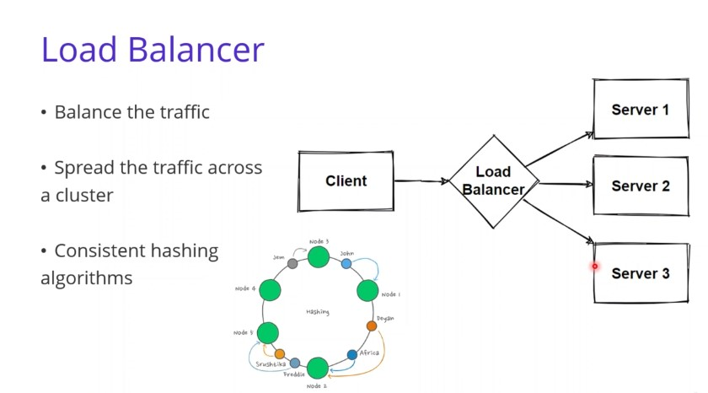

Load balancers are using different kind of **distribution algorithms** to optimally distribute the loads. For example,**Round robin a**lgorithms — works as a **First In First Out (FIFO)**. each server get requests in sequential order.

**Why We are using Load Balancer with Consistent Hashing**

**Consistent hashing** is an algorithms for dividing up data between multiple machines. It works particularly well when the number of machines storing data may change. This makes it a useful trick for system design questions involving large, **distributed databases**, which have many machines and must account for machine failure.

**Consistent hashing**solves the horizontal scalability problem by ensuring that every time we scale up or down, we **don’t have to re-arrange** all the keys or touch all the database servers. That’s why **Consistent hashing**is the best option when working with distributed microservices. In order to increase concurrent request we should **evolve**our **architecture**to **Microservices Architecture.**

**N Layered Architecture**

N-layered architecture is a design pattern used in software development where the system is organized into multiple layers **to achieve separation of concerns, modularity, and maintainability. Each layer has a specific responsibility, and communication between layers is well-defined.** The number of layers can vary, and "N" is used as a placeholder to represent any number of layers. Commonly, you might encounter architectures with three layers (3-tier) or four layers (4-tier), but more complex systems can have additional layers.

**Separation of Concern**

Separation of Concerns (SoC) is a fundamental design principle in software development that advocates breaking a computer program into distinct sections, each addressing a different concern or responsibility.

**The goal is to isolate different aspects of the software to make it more modular, maintainable, and understandable.**

**Each concern or module should focus on a specific aspect of the functionality** and should be relatively independent of other concerns.

**SOLID**

[**https://medium.com/bgl-tech/what-are-the-solid-design-principles-c61feff33685**](https://medium.com/bgl-tech/what-are-the-solid-design-principles-c61feff33685)

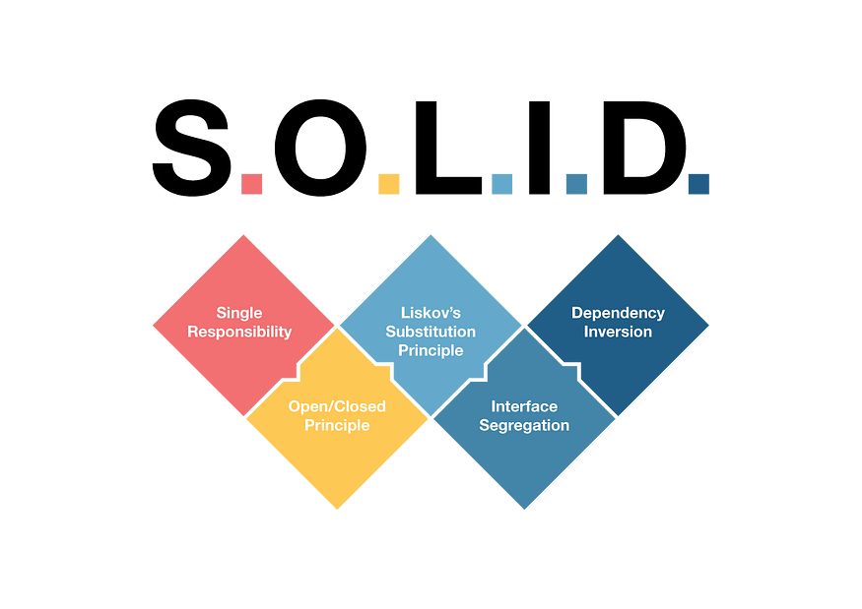

The aim of the SOLID principles is to reduce dependencies, enabling the ability to change code in one area of an application without impacting code in other areas.

# Single Responsibility

**‘There should never be more than one reason for a class to change’**

this means that each module or service should have a single responsibility or purpose.

# Open/Closed Principle

**‘A module should be open for extension but closed for modification’**

* Software entities (classes, modules, functions, etc.) should be open for extension but closed for modification.
* In NestJS, this can be achieved **through the use of dependency injection**, decorators, and the extensibility of modules.

# Liskov’s Substitution Principle

**‘Subclasses should be substitutable for their base classes’**

* Subtypes must be substitutable for their base types without altering the correctness of the program.
* In NestJS, this means that derived classes or services should be able to replace the base classes or services without affecting the behavior of the application.

# ****Interface Segregation****

**‘Many client specific interfaces are better than one general purpose interface’**

* A class should not be forced to implement interfaces it does not use.
* In NestJS, this can be achieved by creating small, specific interfaces that are tailored to the needs of the classes that implement them.

# Dependency Inversion

**‘Depend upon abstractions. Do not depend upon concretions.’**

* High-level modules should not depend on low-level modules. Both should depend on abstractions.
* Abstractions should not depend on details. Details should depend on abstractions

**Service Oriented Architecture (SOA)**

[**https://medium.com/design-microservices-architecture-with-patterns/service-oriented-architecture-1e4716fbca17**](https://medium.com/design-microservices-architecture-with-patterns/service-oriented-architecture-1e4716fbca17)

[**https://docs.oracle.com/cd/E13171_01/alsb/docs30/concepts/introduction.html**](https://docs.oracle.com/cd/E13171_01/alsb/docs30/concepts/introduction.html)

Service-Oriented Architecture (SOA) is a design approach for building software systems that promotes the use of loosely coupled, interoperable, and reusable components or services.

In an SOA, software functionality is organized into services, which are self-contained, modular units of business logic.

These services can be developed, deployed, and scaled independently, and they communicate with each other over a network to achieve specific business goals.

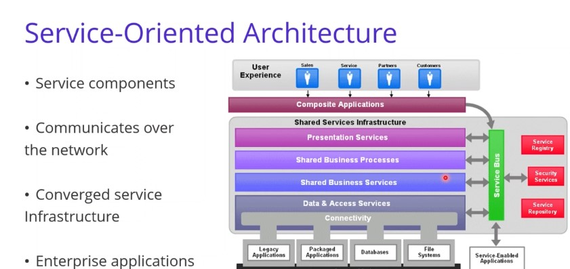

# Communication in SOA

We already saw that in **SOA**communications drive by **Enterprise Service Bus — ESB**systems. They performs integrations between applications, handles **connectivity**and **messaging**, **performs routing**, **converts communication protocols**and potentially manages the composition of multiple requests.

So what is the technology that communication handle for **each components**in **SOA?**

First of all, we should say that communication will be the**inter-service communication**because **SOA components**are **distributed**. And these inter-service communication handle by **SOAP-based web services**.

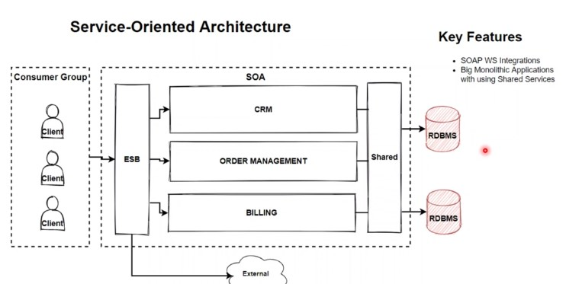

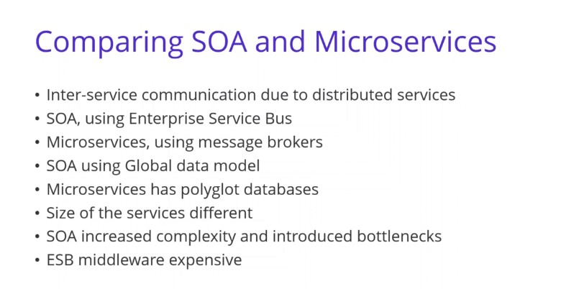

Both are using**Inter-service communication** due to **distributed services**. But in SOA, using **Enterprise Service Bus**, using **heavyweight protocols**, such as **SOAP**, **WSDL**, and **XSD protocols**.

But in microservices, using message brokers, or**direct service-to-service** communication, using lightweight protocols such as **REST**or **gRPC**. Also Data models are different, **SOA**using **Global data model** and**shared databases**, But Microservices has polyglot databases with database per service pattern.

Another**key difference**between SOA and the microservice architecture is the size of the services. SOA is typically used to **integrate large, complex, monolithic applications.** Although services in a microservice architecture almost always**much smaller.**

**Microservices Architecture**

<https://medium.com/design-microservices-architecture-with-patterns/microservices-architecture-for-enterprise-large-scaled-application-825436c9a78a>

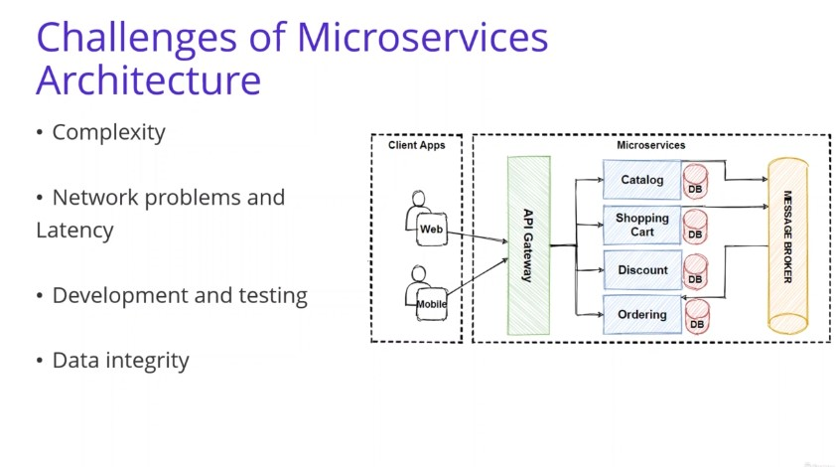

**Decomposition Microservice Architecture**

<https://medium.com/design-microservices-architecture-with-patterns/decomposition-of-microservices-architecture-c8e8cec453e>

**Decompose Microservices**with apply various **Microservices Decomposition Patterns**like **Decompose by Business Capability, Decompose by Subdomain**and **Bounded Context Pattern**.

**Microservices Communications**

<https://medium.com/design-microservices-architecture-with-patterns/microservices-communications-f319f8d76b71>

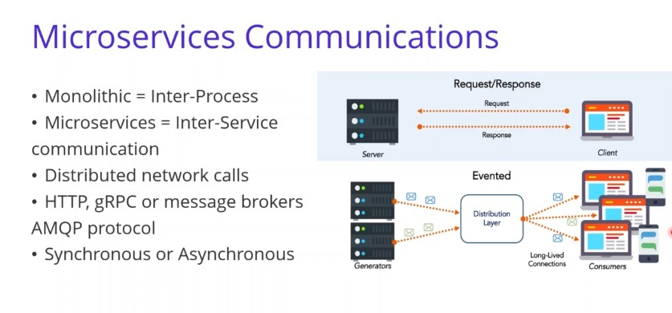

One of the biggest challenge when moving to **microservices**-**based application**is changing the communication mechanism. Because microservices are **distributed**and **microservices communicate**with each other by **inter**-**service communication**on network level.

Each microservice has its own **instance**and **process**. Therefore, services must interact using an **inter**-**service communication**protocols like **HTTP**, **gRPC**or **message brokers AMQP**protocol.

# Microservices Communication Types — Sync or Async Communication

# https://miro.medium.com/v2/resize:fit:875/1*63py5DO08sV7rKOcS8mK-Q.png

## **Synchronous communication**

* Synchronous communication is using **HTTP,HTTPS**or **gRPC protocol**for returning sync response.
* The client sends a request and waits for a response from the service. So that means client code block their thread, until the response reach from the server.
* So that means the client call the server and**block client**their operations.  
  The client code will continue its task when it receives the HTTP server response. So this operation called **Synchronous communication**.

**Asynchronous communication**

* In Asynchronous communication, the client sends a request but it doesn’t wait for a response from the service. **So the key point here is that, the client should not have blocked a thread while waiting for a response**.
* The most popular protocol for this Asynchronous communications is **AMQP (Advanced Message Queuing Protocol)**. So with using **AMQP protocols**, the client sends the message with using message broker systems like **Kafka**and **RabbitMQ queue**. The message producer usually does not wait for a response. This message consume from the subscriber systems in **async**way, and no one waiting for response suddenly.

An **asynchronous communication**also divided by 2 according to implementation. An asynchronous systems can be implemented in a

**one-to-one(queue) mode**

**one-to-many (topic) mode.**

In a **one-to-one(queue)** implementation there is a single producer and single receiver. But in **one-to-many (topic)** implementation has Multiple receivers. Each request can be processed by zero to multiple receivers. **one-to-many (topic)**communications must be asynchronous.  
  
So we will see this communication with the **publish/subscribe**mechanism used in patterns like **Event-driven microservices**architecture in the upcoming articles.

Basically an**event-bus**or **message broker** system is publishing events between multiple microservices, and communication provide with subscribing these events in an **async way**.

If **we’re communicating between services internally within our microservices cluster,** we might also use **binary format communication mechanisms like gRPC**. gRPC is one of the best way to communicate for internal microservice communication, we will see **gRPC**in the upcoming sections.

# Designing HTTP based RESTful APIs for Microservices

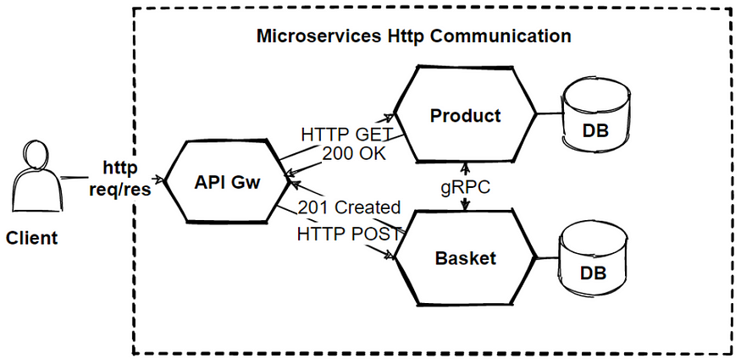

There are **2 type of APIs** when designing sync communication in microservices architecture.

1-**Public APIs** which is APIs calls from the client applications.  
2- **Backend APIs** which is used for inter-service communication between backend microservices.

For **Public APIs**, should be align with client request. Clients can be web browser or mobile application requests. So that means the public API should use **RESTful APIs**over **HTTP protocol**. So **RESTful APIs**should use **JSON**payloads for **request**-**response**, this will easy to check payloads and easy agreement with clients.

For the **backend APIs**, We need to consider network performance instead of easy readable **JSON payloads**. Inter-service communication can result in a lot of network traffic. For that reason, **serialization**speed and payload size become more important. So for the backend APIs, These protocols support **binary serialization**should implement. The protocol alternatives is using **gRPC**or other binary protocols are mandatory.

**REST AND gPRC**

REST is using HTTP protocol, and request-response structured **JSON**objects. API interfaces design based on **HTTP**verbs like **GET-PUT-POST** and **DELETE**.

**gRPC**is basically Remote Procedure Call, that basically invoke external system method over the binary network protocols. Payloads are not readable but its faster that **REST APIs**.

# What is gRPC ?

# **gRPC (gRPC Remote Procedure Calls)** is an open source remote procedure call (RPC) system initially developed at Google. **gRPC**is a framework to efficiently connect services and build distributed systems.

# 

It is focused on high performance and uses the**HTTP/2**protocol to transport binary messages. It is relies on the **Protocol Buffers language**to define service contracts. Protocol Buffers, also known as **Protobuf**, allow you to define the interface to be used in service to service communication regardless of the programming language

It generates cross-platform client and server bindings for many languages. Most common usage scenarios include connecting services in microservices style architecture and connect mobile devices, browser clients to backend services. The **gRPC framework** allows developers to create services that can communicate with each other efficiently and independently from their preferred programming language.

*Once you define a contract with* **Protobuf**, *this contract can be used by each service to automatically generate the code that sets up the communication infrastructure***.** This feature simplifies the creation of service interaction and, together with high performance, makes **gRPC**the ideal framework for creating microservices.

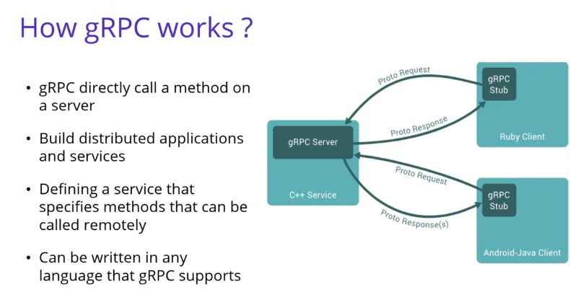

* In **GRPC**, a client application can directly call a method on a server application on a different machine like it were a local object, making it easy for you to build **distributed applications**and services.
* As with many RPC systems, **gRPC**is based on the idea of defining a service that specifies methods that can be called remotely with their parameters and return types. On the server side, the server implements this interface and runs a **gRPC**server to handle client calls. On the client side, the client has a stub that provides the **same methods**as the server.

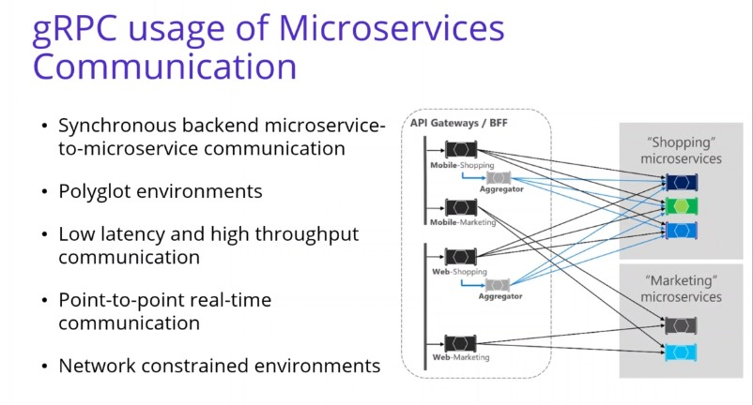

**An aggregator**  
**An aggregator microservice is a component of a microservices architecture that is responsible for collecting and combining data from multiple sources or services. Its primary function is to aggregate information and present a unified view or result to the user or other parts of the system.**

This **Shopping Aggregator**Microservice receives a single request from a client, dispatches it to various microservices, aggregates the results, and sends them back to the requesting client. Such operations typically require synchronous communication as to produce an immediate response.

# Example of gRPC in Microservices Communication

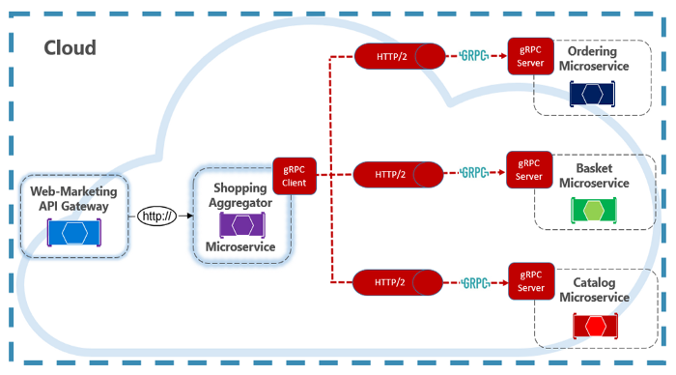

**gRPC communication**requires both client and server components. You can see that **Shopping Aggregator**implements a gRPC client. The client makes synchronous gRPC calls to backend microservices, this backend microservices are implement a **gRPC server**. As you can see that, The gRPC endpoints must be configured for the **HTTP/2**protocol that is required for gRPC communication.

In microservices world, most of communication use **asynchronous communication** **patterns**but some operations require direct calls. **gRPC**should be the primary choice for **direct synchronous communication**between microservices. Its high-performance communication protocol, based on **HTTP/2**and protocol buffers, make it a perfect choice.

# Drawbacks of the direct client-to-microservices communication

We will compare the **API gateway pattern** and the Direct **client-to-microservice communication**. We have understand how to design Restful APIS for our microservices architecture. So for every microservices should exposes a set of **fine-grained endpoints** to communicate each other.

In this view, each microservice has a **public endpoint**, and when we open **public endpoint**from our microservices, it has lots of **drawbacks**that we should consider.

When you build **large**and **complex microservice**-**based applications**for example, when handling dozens of microservices, than these **direct-to-microservices communication**can make problems.

The client try to **handle multiple calls**to **microservice endpoints**but this is not **manageable**. Also if we think that new microservices can be add our application, its really hard to manage those from the client application.

If we expand these problems; It can cause to **lots**of **requests**to the **backend services**and it can create possible **chatty communications**. This approach increases **latency**and **complexity**on the UI side. Ideally, responses should be aggregated in the server side.

Also implementing security and **cross**-**cutting concerns**like **security**and **authorization**for every microservice is not to good way of implementations. These **cross-cutting concerns**should handle in centralized place that can be in internal cluster. Also if there is a **long-running apis**that need to work on **async** **communications**, its hard to implement event-driven publish-subscribe model with **message brokers**from the client applications.

So these are the **drawbacks**of the**direct client-to-microservices** communication. Instead of that we should use**API Gateways** between client and internal microservices.

API Gateways can handle that **Cross-cutting concerns**like **authorization**  
so instead of writing every microservices, authorization can handle in **centralized API gateways**and sent to internal microservices.

Also API gateway manage routing to internal microservices and able to aggreate several microservice request in 1 response.

**problem**

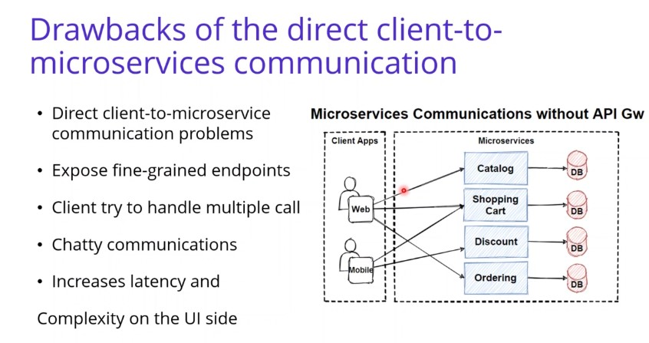

**solution**

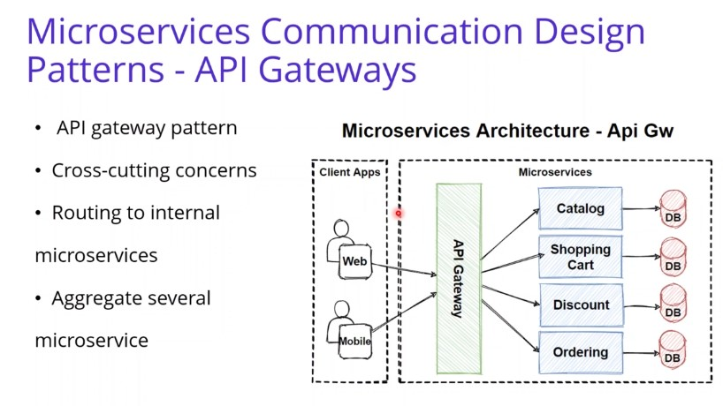

# Design API Gateway — Microservices Sync Communications Design Patterns (**HTTP**, **gRPC)**

# Reference : <https://medium.com/design-microservices-architecture-with-patterns/api-gateway-pattern-8ed0ddfce9df>

# 3 Main Pattern

# Gateway Routing Pattern

# Gateway Aggregation Pattern

# Gateway Offloading Pattern

# 

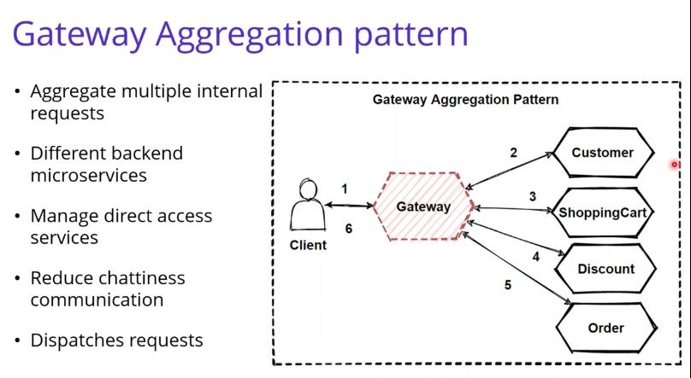

# ****API Gateway****Pattern

The **API gateway pattern** is recommended if you want to design and build **complex large microservices**-**based applications**with multiple client applications. The pattern is similar to the **facade pattern**from object-oriented design, but it is part of a distributed system **reverse proxy**or **gateway routing**for using as a synchronous communication model.

it provides a **single entry point**to the APIs with encapsulating the underlying system architecture. The pattern provides a **reverse proxy**to **redirect**or **route requests**to your internal microservices endpoints. An API gateway provides a single endpoint for the client applications, and it **internally maps**the requests to internal microservices.

the **API gateway**locate between the client apps and the internal microservices. It is working as a **reverse proxy**and routing requests from clients to backend services. It is also provide **cross**-**cutting concerns**like **authentication**, **SSL termination**, and cache

You can see the image that is collect client request in **single entrypoint**and route request to internal microservices.

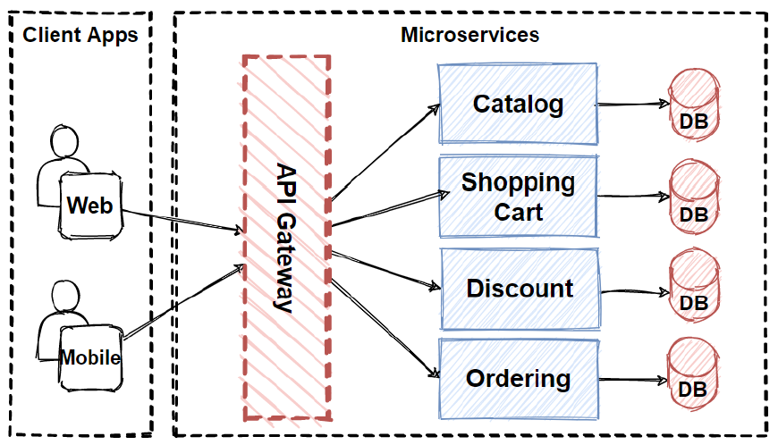

So there are several client applications connect to **single API Gateway**in here. We should careful about this situation, because if we put here a single API Gateway, that means its possible to **single-point-of-failure risk** in here. If these client applications increase, or adding more logic to **business complexity**in API Gateway, it would be **anti-pattern.**

e need to **careful**about using**single API Gateway,** it should be segregated based on **business boundaries**of the client applications and not be a **single aggregator**for all the internal microservices.

# Main Features of API Gateway Pattern

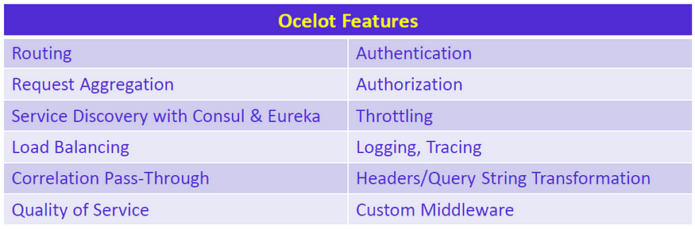

## **Reverse proxy or gateway routing**

This is part of gateway routing pattern features. The API Gateway provides reverse proxy to redirect requests to the endpoints of the internal microservices. Usually, It is using **layer 7 routing**for HTTP requests for request redirections. This routing feature provides to decouple client applications from the internal microservices. So it is separating responsibilities on **network layer**. Another benefit is abstracting internal operations, API GW provide abstraction over the backend microservices, so even there is changes on backend microservices, it wont be affect to client applications. That means don’t need to update client applications when changing backend services.

## **Requests aggregation**

This is part of gateway aggregation pattern features. API Gateway can **aggregate multiple internal microservices**into a single client request. With this approach, the client application sends a single request to the API Gateway. After that API Gateway **dispatches several requests**to the internal microservices and then aggregates the results and sends everything back to the client application in 1 single response. The main benefit of this gateway aggregation pattern is to reduce chattiness communication between the client applications and the backend microservices.

## Cross-cutting concerns and gateway offloading

This is part of gateway offloading pattern features. Since API Gateway handle client request in centralized placed, its best practice to implement cross cutting functionality on the API Gateways.

The cross-cutting functionalities can be;

* **Authentication**and **authorization**
* **Service discovery**integration
* Response **caching**
* **Retry policies**, **circuit breaker**, and QoS
* **Rate limiting**and throttling
* **Load balancing**
* Logging, tracing, correlation
* Headers, query strings, and claims transformation
* IP allowlisting

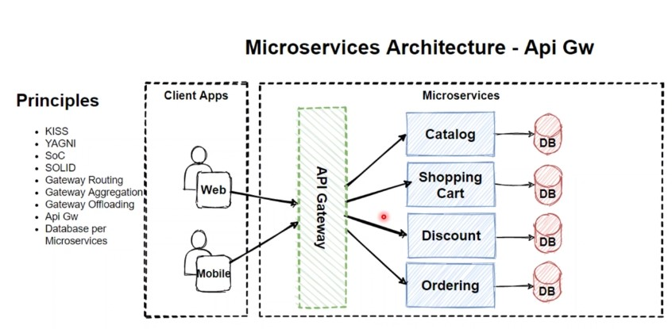

**Backends FOR Frontenda Patterns BFF**

[**https://medium.com/design-microservices-architecture-with-patterns/backends-for-frontends-pattern-bff-7ccd9182c6a1**](https://medium.com/design-microservices-architecture-with-patterns/backends-for-frontends-pattern-bff-7ccd9182c6a1)

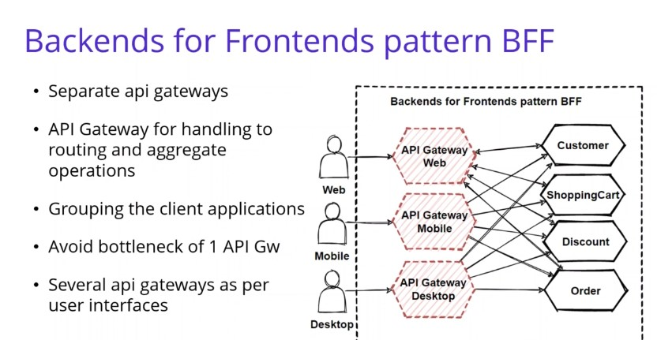

**Service to Service Communications Patterns**

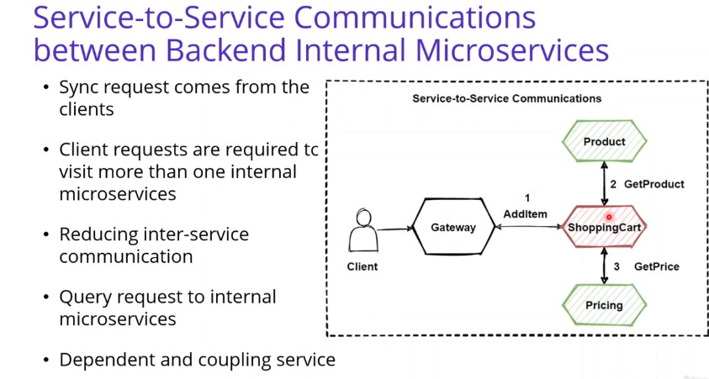

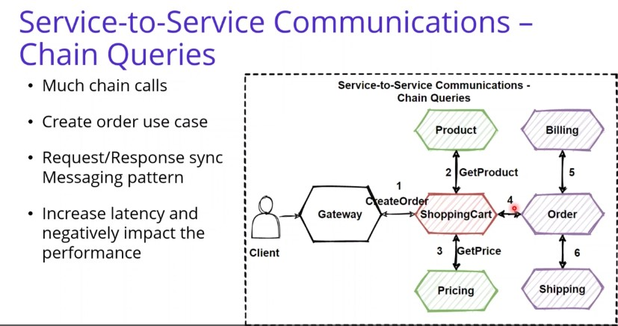

**If middle microservices is down its effect entire system . To avoid such condition :-**

**Sevice Aggregation Pattern**

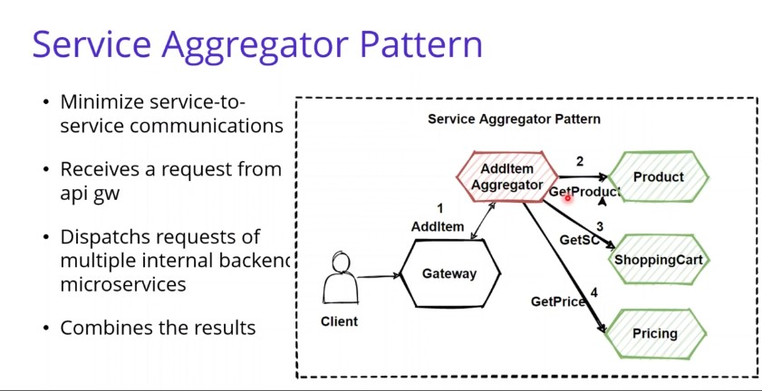

**Service Registry Pattern**

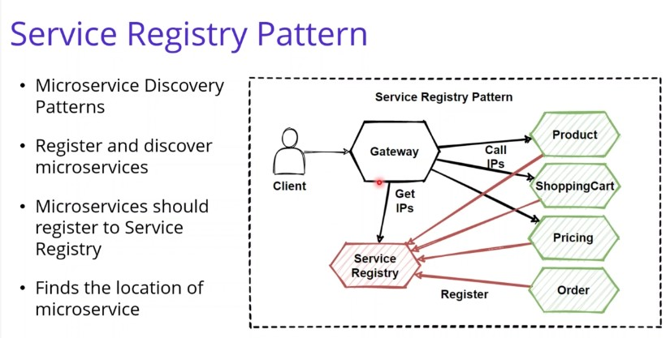

# Microservices Asynchronous Message-Based Communication(async AMQP)

[**https://medium.com/design-microservices-architecture-with-patterns/microservices-asynchronous-message-based-communication-6643bee06123**](https://medium.com/design-microservices-architecture-with-patterns/microservices-asynchronous-message-based-communication-6643bee06123)

**Synchronous communication**

microservices need to call each other and wait some**long operations** until finished

 that **dependency**and **coupling**of microservices will create **bottleneck**and create serious problems of the architecture.

**chain**of **request**and **highly coupled depended**

If we have a few interaction with querying microservices then we should use **HTTP request/response** with resource APIs. But when it comes to busy interactions in communication across multiple microservices, then we should use **asynchronous messaging platforms** like **message broker**systems.

**Asynchronous**

**multiple microservices** are required to **interact**each other and if you want to interact them **without**any **dependency**or make **loosely coupled**, than we should use **Asynchronous message-based communication** in Microservices Architecture. Because **Asynchronous**message-based communication is providing works with **events**. So events can place the communication between microservices. We called this communication is a **event-driven communication.**

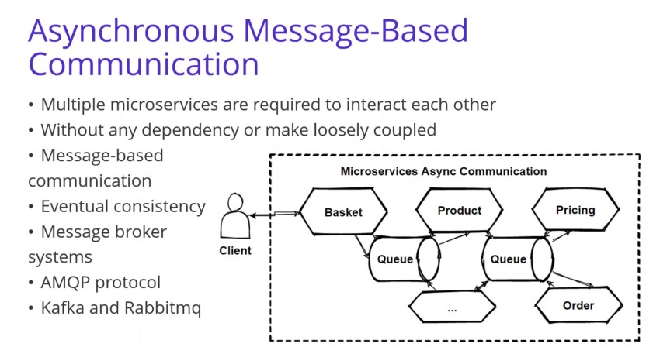

That means if any changes happens in the **Domains**of microservices, it is propagating changes across multiple microservices as an event after that these events consumed by **subscriber microservices**. This e**vent-driven communication** and **asynchronous** **messaging**brings us “**eventual consistency**” that we will discuss this in the upcoming articles.

**AMQP**protocol, the producer send a message and doesn’t wait a response. It only send message and expects that it will consume by **subscriber services**via to message broker systems.

The client microservice sending a message or event to the message broker systems and no need to wait reply. Because it aware of this is **message-based communication,**and it won’t be **respond immediately**. A message or event can includes some data. And these messages are sent through asynchronous protocols like AMQP over the message broker systems like **Kafka**and **Rabbitmq**.

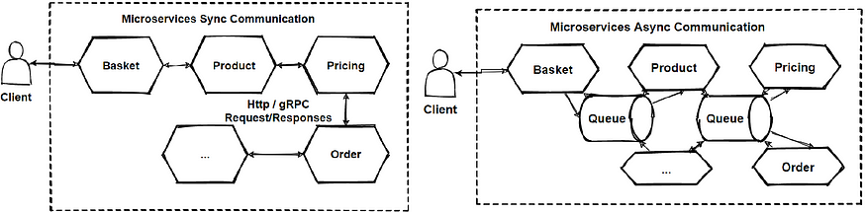

**2 Type of Asynchronous Messaging Communication**

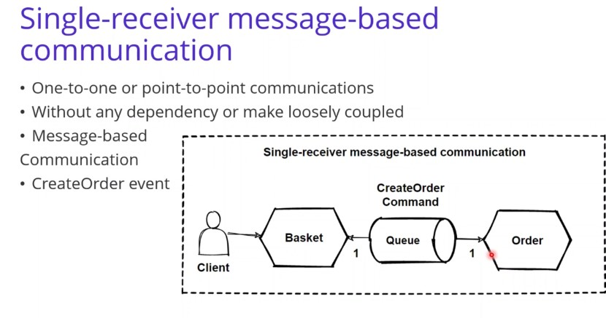

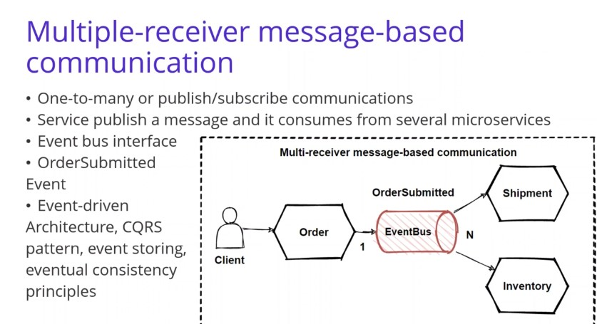

# Design Principles — Dependency Inversion Principles (DIP)

this design principles for software development and it provide to **broke dependency of classes**by **inverting dependencies** and inject dependent classes via **constructor**or property of main class.

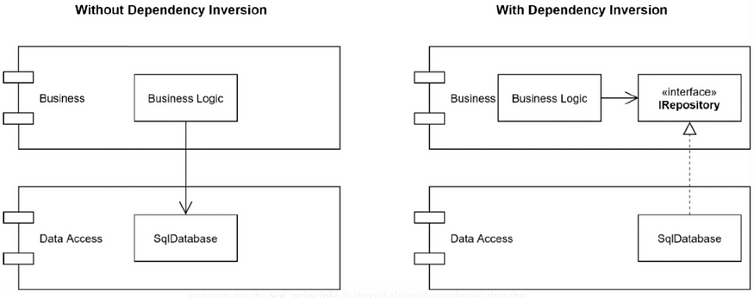

Briefly explain this method; **Upper-level modules**or classes and**lower-level classes**must not be dependent on modules. Lower-level modules must be dependent on higher-level modules (interfaces of modules). For short, we call it **Dependency** **Inversion**.

See the above picture again, On the **left side**we found an **Layered** **Application**where the Business Logic depends on the SqlDatabase implementation. It is a coupled way to write code.

On the **right side**, by adding an **IRepository**and applying **DIP**then the **SqlDatabase**has its dependency pointing inwards. So its basically broke the dependency with layers and inject them with using DIP principle.

# Publish–Subscribe Design Pattern

**Publish–subscribe** is a messaging pattern, that has sender of messages which’s are called **publishers**, and has specific receivers which’s are called **subscribers**. 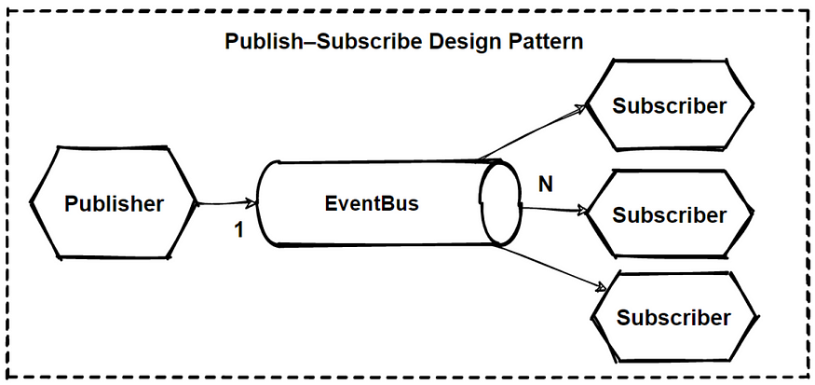

**publishers**don’t send the **messages**directly to the subscribers. Instead categorize **published messages**and send them into message broker systems without knowledge of which **subscribers**are there. Similarly, subscribers express **interest**and only receive messages that are of interest, without knowledge of which **publishers**send to them.

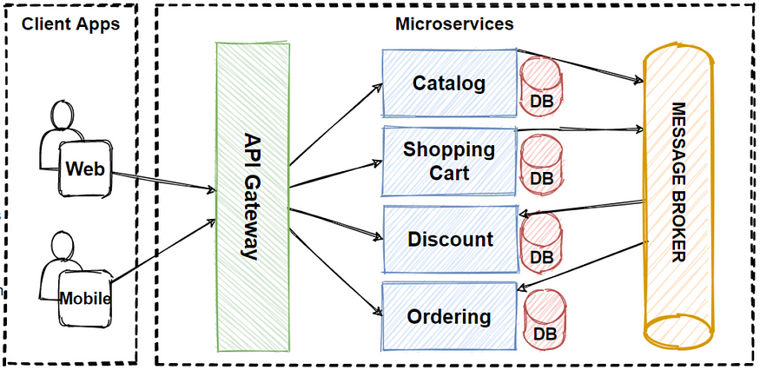

**Kafka and RabbitMQ Architecture**

**Message Brokers** ?

1. **Kafka**
2. **RabbitMQ**

**Message broker**  
**Message brokers play a crucial role in microservices architectures by facilitating communication and coordination between loosely coupled, independently deployable services. Here's how message brokers are typically used in microservices**

**Some features:**

* **Decoupling**
* **Async Communication**
* **Event-Driven Architecture**
* **Scalability**
* **Fault Tolerance**
* **Load Balancing**
* **Ordering and Sequencing**
* **Integration with Legacy System**
* **Handling Bursty Loads**
* **Protocol Translantion**

